Itinerary Planning
Annual Report
Editorial highlights, 2019-20

UPFRONT
Keynote
Mario Alovisi, vice president revenue management and itinerary design at Costa Cruises, introduces the 2019 edition of our Itinerary Planning special annual report. Alovisi covers a wide range of topics, including industry developments, travel trends, brand values, shore excursions and the key components of a perfect itinerary.

Marketwatch
An eclectic round-up of the top global port and destination news, views, opinions and insights. Our extended story in this issue will take a leisurely look at Celebrity Cruises’ and Silversea Cruises’ itineraries in their big anniversary years.

FEATURES
Roundtable: Problem solving
The modern itinerary planner has to be a skilled problem solver but many of the challenges that confront the role are industry-wide and require international consensus. Itinerary planners travel the world and frequently confront these issues in difficult and sometimes public circumstances. We want to help spread the solutions and refocus attention on more positive topics. Contributors include:
- Federico Bartoli, itinerary planning director, Costa Cruises
- Justin Poulson, vice president of strategic pricing and itinerary planning, Silversea Cruises
- Neil Duncan, head of yield and planning, Marella Cruises
- Hugues Lamy, director of port operations, V. Ships Leisure

Feature: Guest expectations
With such high repeat rates in the industry, passengers have developed increasingly higher expectations with the benchmark set at the standard achieved by the best cruise that they have ever experienced. Within this context, our expert contributors set clear expectations for their port and destination partners:
- Matthew Rutherford, vice president of revenue management and deployment, Carnival Australia
- Emilio Freeman, vice president of destinations and revenue management, SeaDream Yacht Club
- Harold Quesada, manager of deployment and strategy, Disney Cruise Line
- Alvaro Platas, corporate strategy and itinerary planning manager, Pullmantur

PLANNER PERSPECTIVES
Our planner perspective interviews share essential knowledge and wisdom about port and destination improvement for even greater levels of passenger satisfaction:
- Claudius Docekal, vice president of deployment, Crystal Cruises
- Ugo Savino, director of deployment and itinerary planning, Carnival Cruise Line
- Juan Trescastro, senior director of itineraries, destinations and government relations, Virgin Voyages

REPORTS
A better shore experience
Shorex professionals continue to build creative combination tours, many of which would be hard for passengers to replicate alone. But passengers have alternatives, whether it’s to explore a destination alone or travel with a local operator. Cruise lines need to win this business back. Our chosen experts give us some canny insights into how they are tackling this challenge:
- Sture Myrmell, president, P&O Cruises Australia
- Martin Lister, head of itinerary planning and destination experience, Fred. Olsen Cruise Lines
- JP Salazar, manager of land programmes, The Ritz-Carlton Yacht Collection
- Kristin Badgett, VP Revenue Management & Deployment, Windstar Cruises

VIEWPOINTS
Throughout this edition there will be a series of mini Viewpoints from senior industry influencers. We’ll be asking these people to share their thoughts on topical issues, voice their opinion on industry challenges or simply to highlight examples of excellence in practice:
- Jack Cochrane, senior itinerary planner, Carnival Corporation
- Kris Willassen, itinerary planner, Hurtigruten
- David Selby, consultant to cruise ports, destinations, cruise lines, investors and suppliers

Association highlights
Renowned port and destination associations share their members’ latest news and highlight some key initiatives that they are currently developing. Contributors include:

- Kay Greenway, Cruise Britain
- Mariia Luzhanska, Black Sea Ports
- Alison Downes, Cruise Scotland
- Inge Tangeras, Cruise Norway
- Claus Bødker, Cruise Baltic
- Abie Wentzel, Cruise Africa
- MedCruise General Assembly highlights
- Cruise Europe conference highlights

Regional spotlight
Beth Bodensteiner from Holland America Line talks about a specific cruise region (to be confirmed) and answer some questions about why it’s such a compelling destination for cruise lines and their passengers. This spotlight will investigate the opportunities and challenges for the region and review the attributes that have made it a popular choice to date.

PLUS: Port, destination and shore excursion interviews and reports from around the world

- North America & Canada
- South America
- Central America & Caribbean
- Northern Europe
- Mediterranean and Black Sea
- Middle East
- Africa, Gulf and Indian Ocean
- Asia Pacific

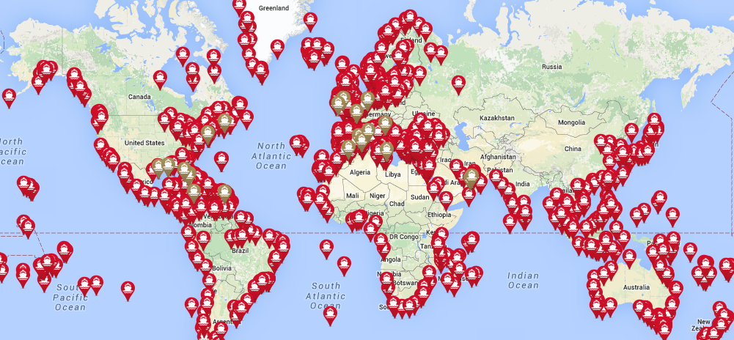
FURTHER INFORMATION
Partners
Cruise & Ferry is proud to partner with the following industry organisations:

Contacts
Rebecca Gibson, Associate Editor Jon Ingleton, Executive Editor
Email: rebecca.gibson@tudor-rose.co.uk Email: jon.ingleton@tudor-rose.co.uk
Tel: +44 116 222 9900 Tel: +44 116 222 9900
Note: this editorial plan is subject to the interview availability of the organisations and individuals listed. Alternative contributors will be found if they are required.

