Editorial Highlights
Autumn/Winter 2020

UPFRONT
Keynote
Richard Fain, president and CEO of Royal Caribbean Cruises Ltd, provides the keynote for our second issue of 2020, sharing his thoughts about changing industry dynamics from brands and ship types to cruise regions and source markets. Fain’s regular annual contribution to Cruise & Ferry Review continues to be an eagerly awaited perspective across the industry.

Marketwatch
An eclectic round-up of global cruise and ferry news, views, opinions and insights that cover all segments of the passenger shipping industry. Our extended story in this issue looks into how cruise and ferry passenger volumes have grown in recent years and seeks an expert view to forecast future traffic.

CRUISE BUSINESS
Roundtable: The sustainability agenda
Our roundtable in this issue invites cruise line CEOs to discuss the highlights in their latest sustainability reports and comment on future initiatives. A wide range of initiatives will be discussed from LNG and shore power to sustainable materials and advanced technology. The roundtable will be immediately followed by an interview with Paul Holthus, founding president and CEO of World Ocean Council.

PLUS Executive interviews with:
- Christine Duffy, president, Carnival Cruise Line
- Roberto Martinoli, president, Silversea Cruises
- Neil Palomba, president, Costa Cruises
- Mário Ferreira, owner, Mystic Cruises and Niko Cruises
- Arild Myrvoll, CEO, Havila Voyages
- Jan Swartz, president, Princess Cruises
- Charles Robertson, president, American Cruise Lines
- Glen Moroney, owner and chairman, Scenic Group
- Kelly Craighead, president and CEO, Cruise Lines Industry Association

FERRY BUSINESS
Roundtable: Inspiring passenger confidence
Long-haul tourism will take longer to recover from the pandemic, providing an opportunity for the ferry industry to bounce back faster and capitalise on our deep-rooted desire to travel. Some industry commentators are predicting a renaissance for passenger ferry travel, with the sector’s long-term fortunes relying on its ability to quickly engender loyalty among its new broader customer demographic.

PLUS Executive interviews with:
- Mike Corrigan, CEO, Interferry
- Francis Portelli, managing director, Virtu Holdings
- Amy Scarton, CEO, Washington State Ferries
- Fran Collins, CEO, Red Funnel Ferries
- Kathryn Banks, director, Pentland Ferries
- David Sopta, president, Jadrolinija
- Johan Roos, executive director of EU and IMO affairs, Interferry
- Michael Grey, freelance correspondent

BUILDING & REFURBISHMENT
Feature: Classification outlook
The utilisation of remote services in recent months has transformed the current balance of classification services. Class societies have also provided essdential support and innovation across their portfolio of traditional services. We talk to leading societies about the new services that they’ve introduced and ask them about the implications for the long-term classification landscape.

Report
Cruise order book – cruise line and shipyard executives share their highlights and talk about recent launches. We also review the progress being made on key newbuilds that are due to debut in H2 2020:

Ship name | Cruise Line | Shipyard | Delivery date
Mardi Gras | Carnival Cruise Line | Meyer Turku | H2 2020
Ultramarine | Quark Expeditions | Brodosplit | H2 2020
Celebrity Beyond | Celebrity Cruises | STX France | H2 2020
Crystal Endeavour | Crystal Cruises | MV Werften | H2 2020
Odyssey of the Seas | Royal Caribbean International | Meyer Werft | H2 2020
MSC Virtuosa | MSC Cruises | STX France | H2 2020
Silver Moon | Silversea Cruises | Fincantieri | H2 2020
Costa Firenze | Costa Cruises | Fincantieri | H2 2020
Scenic Eclipse II | Scenic Cruises | Uljanik | H2 2020
Le Surville | Ponant | Vard Norway | H2 2020
Coral Geographer | Coral Expeditions | Vard Vung Tau | H2 2020

PLUS:
- Ferry order book – a review of the highlights in the global order book that are continuing to keep this industry sector buoyant.
- Repair and refurbishment highlights – highlights of significant projects completed in H1 2020 and a look ahead to some of the deliveries scheduled for H2 2020.

MARINE OPERATIONS
Feature: Enhancing safety at sea
The requirements for innovation and continuous improvement of operational safety is paramount. Inevitably, technology has a growing role in enhancing every aspect of safety and security for ships, ports, marine facilities, passengers and crew. Research and development of new and improved products and services remains essential to further enhance an already strong industry safety record. In this feature we ask suppliers to share news about their product innovations and emerging technologies.

Featuring an interview with Heike Deggim, director of the maritime safety division at International Maritime Organization

PLUS Executive interviews with
- Linden Coppell, director of sustainability, Norwegian Cruise Line
- Jan Helge Pile, senior vice president of marine and technical operations, Color Line
- Erik Lewenhaupt, head of sustainability, Stena Line Group
- Dr Cleopatra Doumbia-Henry, president, World Maritime University
Additional topics covered:

- Safety and security
- Telecommunications
- Water and waste management
- Environmental and hygiene
- Heating, ventilation and air conditioning

ONBOARD EXPERIENCE
Feature: Reviving the refurbishment market
Interior outfitters have been hit hard during the pandemic and yet they have remained steadfastly positive about the future of the industry. While their revenues have been decimated and workforces sadly depleted, outfitting businesses have been reviewing project procedures and processes to make improvements for the benefit of their clients. In this report we speak to some of the leading names in the field to share their insights and wisdom.

Report: Cruise Ship Interiors Expo preview
All the big names in the cruise interiors business are now heading to London in December and we’re hosting the VIP lounge once again. In this special report we’ll share highights of the conference, exhibition and social scene and give the inside scoop on what not to miss at the event!

PLUS interviews with
- Erik Wolf, World Food Travel Association
- Andy Yuill, SMC Design
- Fredrik Johansson, Tillberg Design
- Greg Walton, Studio DADO
- Marco de Jorio, De Jorio Design
- Brian McConville, MJM Marine
- Mike Oliver, Trimline
- Gabriele Cafaro, Marine Interiors
NEXT ISSUE in June 2020 Cruise & Ferry Interiors celebrates the work of the individuals
and companies whose creative genius and endeavour combine
to deliver amazing interiors at sea. It’s the official magazine for
Cruise Ship Interiors Expo, and the only one in the VIP Lounge.

For more information email Shelly Palmer or your Cruise & Ferry
account manager.

It’s the only magazine in the inudstry and will
be the only magazine in the delegate bag!

PORTS & DESTINATIONS
Feature: Rebuilding cruise tourism
Introduced by Chiara Giorgi, global event director, Seatrade Cruise Events, this feature seeks expert commentary from two tourism experts as cruise lines slowly starting to resume operations. Caribbean communities have been hit hard by the loss of tourism revenue, likewise port cities around the world. Neil Walters, president of the Caribbean Tourism Organisation and Chen Jining, chairman, World Tourism Cities Federation, provide their perspectives on the rebuilding job in progress.

Interview: A planner’s perspective
Itinerary planners are regulars on the speaker circuit and this series of interviews will see CFR talking with a selection of these familiar and well-informed industry experts to get the inside track on key issues over the next few years. Seabourn’s Timothy Littley kicked off the series in our Spring/Summer 2020 issue and news will follow shortly about the second planner for our Autumn/Winter 2020 issue.

NEXT ISSUE in November 2020
Still the only publication dedicated entirely to the multi-disciplinary activities comprising itinerary planning – an essential read for every stakeholder.

Email Kimberley McLean for more information about the features and contributors that are scheduled to be included in the 2020 issue.

Regional reports
A series of interviews, commentaries and reports about ports, destinations and shore excursions in each of the following regions:
- North America & Canada
- South America
- Central America & Caribbean
- Northern Europe
- Mediterranean & Black Sea
- Middle East
- Africa, Gulf & Indian Ocean
- Asia Pacific

www.cruiseandferry.net/resources/cruise-ports-of-the-world
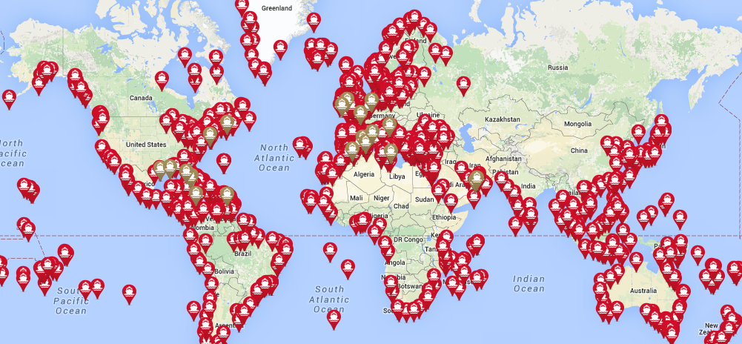

FURTHER INFORMATION
Events
Copies of Cruise & Ferry magazines will be available at the following events:
- Ferry Safety & Technology Conference
- Ferry Shipping Summit
- Seatrade Cruise Global
- Poisidonia
- Cruise Ship Interiors Expo America
- Electric & Hybrid Marine World Expo
- SMM
- Europort
- Cruise Europe Conference
- Greenport Cruise Congress
- MedCruise General Assembly
- Canadian Ferry Operators Conference
- IMPA London
- Interferry Conference
- Oceans 2000
- The Future of the Naval Architect
- Sustainable Ocean Summit
- International Cruise Summit
- Cruise Ship Interiors Expo Europe
- ClIA Executive Partner Summit

Partners
Cruise & Ferry Review is proud to partner with the following industry organisations:

Contacts:
Rebecca Gibson, Associate Editor Jon Ingleton, Executive Editor
Email: rebecca.gibson@tudor-rose.co.uk Email: jon.ingleton@tudor-rose.co.uk
Tel: +44 116 222 9900 Tel: +44 116 222 9900

Note: this editorial plan is subject to the interview availability of the organisations and individuals listed. Alternative contributors will be found if they are required.

