Editorial Highlights
Autumn/Winter 2019

UPFRONT
Keynote
Richard Fain, president and CEO of Royal Caribbean Cruises Ltd, provides the keynote for our second issue of 2019, sharing his thoughts about changing industry dynamics from the brands and ship types to cruise regions and source markets. Fain’s regular annual contribution to International Cruise & Ferry Review continues to be eagerly anticipated across the industry.

Marketwatch
An eclectic round-up of the top global cruise and ferry news, views, opinions and insights that cover all segments of the passenger shipping industry. Our extended story in this issue will congratulate Celebrity Cruises, Silversea Cruises, Moby Lines and Viking Cruises on their big anniversaries.

CRUISE BUSINESS
Roundtable
Boardroom priorities: Our roundtable in this issue invites expedition cruise line CEOs to share insights about the dramatic growth of this segment. 2019 will be remembered as a tipping point for the expedition market, with stunning new ships being launched to deliver extraordinary adventures. What predictions will our panel make for this rapidly growing niche market.

PLUS Executive interviews with:
- Felix Eichhorn, president, AIDA Cruises
- Christine Duffy, president, Carnival Cruise Line
- Tom Wolber, president and CEO, Crystal Cruises
- Jeff Vahle, president, Disney Cruise Line
- Karl Pojer, CEO, Hapag Lloyd Cruises
- Gianni Onorato, chief executive, MSC Cruises
- Andy Stuart, president, Norwegian Cruise Line
- Doug Prothero, president, The Ritz-Carlton Luxury Collection
- Ellen Bettridge, president and CEO, Uniworld Boutique River Cruise Collection
- Tom McAlpin, CEO, Virgin Voyages
- Kelly Craighead, president and CEO, Cruise Lines Industry Association

FERRY BUSINESS
Roundtable: State of the Industry
Our second roundtable of 2019, chaired by Simon Johnson, takes an holistic view of the state of the ferry industry. What are the industry’s greatest opportunities and threats? How must ferry lines collaborate to ensure that the industry can continue to thrive and promote a more sustainable future while also battling the ongoing threat of transportation alternatives?

PLUS Executive interviews with:
- Mike Corrigan, CEO, Interferry
- Freda Newton, CEO, Loch Ness by Jacobite
- Stuart Garrett, managing director, Serco NorthLink Ferries
- Francis Portelli, managing director, Virtu Ferries
- David Stretch, managing director short-sea routes, P&O Ferries
- Kym Sayers, CFO, Spirit of Tasmania
- Merideth Tall, founder and chair, Clipper Navigation
- Michael Grey, freelance correspondent

BUILDING & REFURBISHMENT
Feature: Ship of the Year
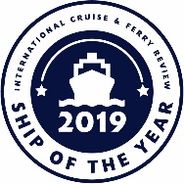
This feature report will celebrate the very best cruise, river cruise and ferry ships that have been or will be launched this year. Our editorial team and advisors will put together a shortlist of cruise ships and ferries across each of the main ship types and then leave our print and online audience to decide which are most worthy of our Ship of the Year gongs.

Report
Cruise order book – cruise line and shipyard executives share their highlights and talk about recent launches. We also review the progress being made on key newbuilds that are due to debut in H2 2019.

Ship name | Cruise Line | Shipyard | Delivery date
Scenic Eclipse | Scenic | Uljanik | Q3, August
Le Dumont D’Urville | Ponant | Fincantieri/Vard | Q3, September
Carnival Panorama | Carnival Cruise Line | Fincantieri | Q3
Azora | The Ritz-Carlton Yacht Collection | Astillero Barreras | Q3
Costa Smeralda | Costa Cruises | Meyer Turku | Q4, October
Norwegian Encore | Norwegian Cruise Line | Meyer Werft | Q4, October
Hanseatic Inspiration | Hapag-Lloyd Cruises | Fincantieri/Vard | Q4, October
Magellan Explorer | Antarctica21 | ASENAV | Q4, October
MSC Grandiosa | MSC Cruises | Chantiers d’Atlantique | Q4, October
Sky Princess | Princess Cruises | Fincantieri | Q4, October
Flying Clipper | Star Clippers | Brodosplit | Q4, December

PLUS:
- Ferry order book – a review of the highlights in the global order book that are continuing to keep this industry sector buoyant
- Repair and refurbishment highlights – highlights of significant projects completed in H1 2019 and a look ahead to some of the deliveries scheduled for H2 2019

MARINE OPERATIONS
Feature: Safety at Sea
Our annual feature presents a series of short articles about products and services that improve safety and security in passenger shipping. Each mini article presents the supplier pitch, encouraging the reader to judge the suitability of the offer for their own fleet. We will endeavour to cover a range of product areas and encourage relevant companies to submit a short product pitch for consideration.

Interview: Regulating the marine environment
In this feature interview we talk to Kitack Lim to celebrate his tenure as his term in office as secretary general of the International Maritime Organization comes to a close. How does Lim view his legacy and what initiatives has he set in motion that will contribute to a healthier maritime environment?

PLUS:
- Bridge equipment
- Telecommunications
- Water and waste management
- Environmental and hygiene
- Heating, ventilation and air conditioning

ONBOARD EXPERIENCE
Feature: Cruise Ship Interiors Expo highlights
All of the big names in the cruise interiors business are going to Miami in June and we’re hosting the VIP pavilion. In this special highlights report we’ll share news from the conference, exhibition and social scene and the inside scoop from our very important friends!

Report: Interior influencers
As a neat sidebar to our interiors reporting in Miami, we will be tipping our hat to some of the most influential names in passenger ship design. We’ll also seek a few words of sage advice from each of them for shipowners who are currently looking to engage their own dream team to conceive and deliver another set of amazing ship interiors.

PLUS interviews with:

- Fredrik Johansson, Tillberg Design
- Andy Yuill, SMC Design
- Greg Walton, Studio Dado
- Brian McConville, MJM Interiors

NEW in June 2019… Cruise & Ferry Interiors celebrates the work of the individuals
and companies whose creative genius and efforts combine
to deliver amazing interiors at sea. It’s the official magazine for
Cruise Ship Interiors Expo and the only one in the delegate bag!

For more information email Shelly Palmer or your Cruise & Ferry
account manager.

It’s the only magazine in the inudstry and will
be the only magazine in the delegate bag!

PORTS & DESTINATIONS
Feature: World Tourism Trends and Wisdom
This feature story takes a high-level view of the World Tourism Organisation’s perspective on data, policy and governance, quality, competitiveness, destination management, tourism products and initiatives. From within this giant library of information and knowledge, what wisdom should the cruise industry be seeking in order to better manage the future growth of the industry while maintaining strong relationships with destinations and communities at a local level?

This feature will be written by our in-house team who will also seek ideas and examples from ports and destinations around the world.

Interview: A planner’s perspective
Itinerary planners are regulars on the speaker circuit and we are often treated to some gems of wisdom. In a new series of interviews over the next few years we will talk to a selection of these familiar and well-informed industry experts to get the inside track on key issues. News will follow shortly about the first planner on our feature interview itinerary.
NEXT ISSUE: October 2019
ITINERARY PLANNING: SPECIAL REPORT 2019
Still the only publication dedicated entirely to the multi-disciplinary activities comprising itinerary planning – an essential read for every stakeholder, with more cruise line executives contributing than ever before!
Email Kimberley McLean for more information about the features and cruise line executives who have already agreed to contribute to this new edition.

Regional reports
A series of interviews, commentaries and reports about ports, destinations and shore excursions in each of the following regions:
- North America & Canada
- South America
- Central America & Caribbean
- Northern Europe
- Mediterranean & Black Sea
- Middle East
- Africa, Gulf and Indian Ocean
- Asia Pacific

www.cruiseandferry.net/resources/cruise-ports-of-the-world
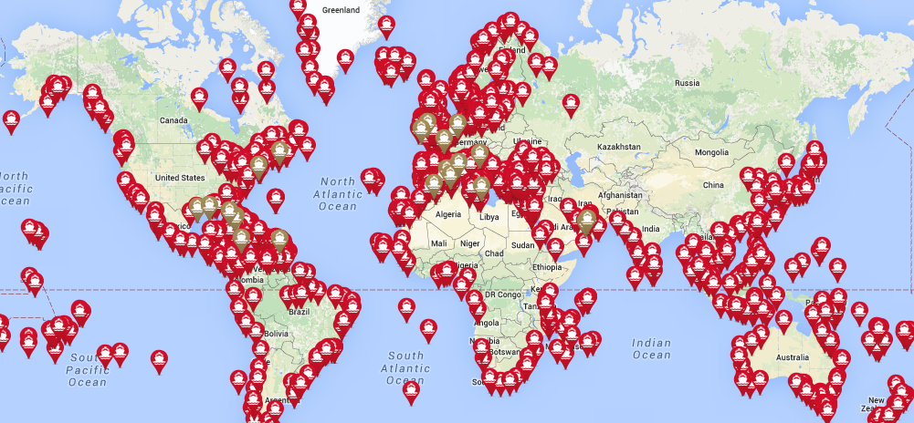

FURTHER INFORMATION
2019 Events
Copies of Cruise & Ferry magazines will be available at the following events:
- Ferry Safety & Technology Conference
- Ferry Shipping Conference
- Seatrade Cruise Global
- Poisidonia Sea Tourism Forum
- Norshipping
- Cruise Ship Interiors Expo (C&F Interiors)
- Electric & Hybrid Marine World Expo
- Europort
- Adriatic Sea Forum
- Cruise Baltic Conference
- Cruise Europe Conference
- GreenPort Congress
- MedCruise General Assembly
- CFOA Conference
- IMPA
- Interferry
- Oceans 2019
- Sustainable Ocean Summit
- Int. Cruise Summit (Itinerary Planning)

Partners
International Cruise & Ferry Review is proud to partner with the following industry organisations:

Contacts
Rebecca Gibson, Associate Editor Jon Ingleton, Executive Editor
Email: rebecca.gibson@tudor-rose.co.uk Email: jon.ingleton@tudor-rose.co.uk
Tel: +44 116 222 9900 Tel: +44 116 222 9900

Note: this editorial plan is subject to the interview availability of the organisations and individuals listed. Alternative contributors will be found if they are required.

