Editorial Highlights
Autumn/Winter 2018

UPFRONT
Keynote
Richard Fain, chairman and CEO, Royal Caribbean Cruises Ltd., takes time out of another hectic year to contribute the keynote for our Autumn/Winter 2018 issue. Fain will share news and his views about the performance and development of the six cruise brands that he leads. Fain’s regular annual contribution to International Cruise & Ferry Review is always a good read.

Marketwatch
An eclectic round-up of the top global cruise and ferry news, views, opinions and insights, which cover all segments of the passenger shipping industry.

CRUISE BUSINESS
Roundtable: Niche cruising
Most of the major river cruise operators have new ships debuting in 2018, while expedition ship order numbers continue to grow and the ultra-luxury market is booming. Onboard technologies and facilities are evolving at quite a pace and niche operators are also making significant improvements to their shore excursion offering. We talk to the CEOs of leading brands to discuss the market challenges and opportunities that lie ahead.

PLUS executive interviews with:
- Pierfrancesco Vago, executive chairman, MSC Cruises
- Stein Kruse, CEO, Holland America Line
- Andy Stuart, CEO, Norwegian Cruise Line
- Jan Swartz, president, Princess Cruises
- Tom Wolber, president and CEO, Crystal Cruises
- Anthony Connelly, president, Disney Cruise Line
- Christine Duffy, president, Carnival Cruise Line
- Navin Sawhney, COO, Ponant
- Lars Clasen, managing director, The Ritz-Carlton Yacht Collection
- Neil Palomba, president, Costa Cruises
- Felix Eichhorn, president, AIDA Cruises
- Cindy D’Aoust, president and CEO, Cruise Lines Industry Association

FERRY BUSINESS
Roundtable: Fleet revitalisation
New ships are setting higher expectations for ferry passengers and new technologies are enabling greater operational efficiencies and environmental leadership. We speak to the CEOs of major ferry lines to investigate industry revitalisation programmes for public spaces and below deck to enhance the customer experience and improve bottom line profits.

PLUS executive interviews with:
- Mike Corrigan, CEO, Interferry
- Paul Luxon, CEO, Condor Ferries
- Christophe Mathieu, CEO, Brittany Ferries
- Andrew Sheen, managing director, Irish Ferries
- Susan Schrempf, CEO, Owen Sound Transportation Company
- Niels Smedegaard, CEO and president, DFDS
- Kym Sayers, CFO, Spirit of Tasmania
- Mike Grainger, chairman, TT-Line
- Supan Pichaironarongsongkram, chair, Chao Phraya Express Boats
- German Orozco, CEO, Ultramar
- Mary Ann Pastrana, senior executive, Archipelago Philippine Ferries
- Johan Roos, director of Regulatory Affairs, Interferry

BUILDING & REFURBISHMENT
Feature
Cruise order book – cruise line and shipyard executives share their highlights and talk about recent launches as well as the progress being made on the newbuilds due out in H2 2018. This regular feature will include a special extended interview with the king of newbuilds, Harri Kulovaara, executive vice president of Maritime and Newbuilding at Royal Caribbean Cruises Ltd.

Cruise Line | Ship name | Yard | Delivery
Scenic Cruises | Scenic Eclipse | Uljanik | September 2018
Star Clippers | Flying Clipper | Brodosplit | September 2018
Ponant | Le Champlain | Vard | September 2018
Mystic Cruises | World Explorer | WestSea Yard | October 2018
Holland America Line | Nieuw Statendam | Fincantieri | November 2018
Aida Cruises | AIDAnova | Meyer Werft | November 2018
Celebrity Cruises | Celebrity Edge | STX France | December 2018

Ferry order book – a review of the highlights in the global order book that are continuing to keep this industry sector buoyant and a guide to some of the most popular yards in the sector.

Report: Engine room
Our annual engine room report reviews the power, propulsion and control systems that are currently being specified and installed onboard passenger ships. We will focus on cruise ships and ferries due for delivery in H2 2018 and seek supplier insights to anticipate the arrangements for ships in 2019 and beyond.

PLUS:
- Repair and refurbishment highlights
- Water treatment
- Ship equipment

MARINE OPERATIONS
Feature: Safety at sea
Our annual feature presents a series of short articles about products and services that improve safety and security in passenger shipping. Each mini article presents the supplier pitch, encouraging the reader to judge the suitability of the offer for their own fleet.

Interview: People first
During the State of the Industry debate at Seatrade Cruise Global 2018 in Fort Lauderdale, Florida, Carnival Corporation’s president and CEO Arnold Donald stated that his company must recruit over 34,000 staff annually. We speak to a leading HR practitioner to investigate the principles, systems and processes that must be implemented to manage staff recruitment and retention.

PLUS:
- Bridge equipment
- Safety and security
- Environment and hygiene
ONBOARD EXPERIENCE
Feature: Onboard entertainment
Cruise and ferry executives discuss the entertainment staples that are expected onboard their vessels and explore some of the often forgotten and zany additions that deliver the perfect mix of entertainment options. Selected product and service companies join the conversation, commenting on their contribution to delivering memorable onboard experiences:
- Michael Day, vice president of Entertainment, Prestige Cruise Holdings
- Richard Ambrose, vice president of Entertainment, Norwegian Cruise Line
- Carlos Torres de Navarra, vice president of Commercial Port Operations, Carnival Cruise Line
- Peter Arvidsson, COO, Stena Line

Interview: Onboard revenue
In this special interview we talk to Paul Goodwin, executive vice president of Onboard Revenue at Holland America Line, to get his insights on balancing high passenger satisfaction ratings with a strong bottom line.

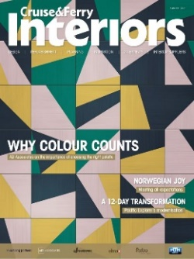
Special supplement: Cruise & Ferry Interiors

Cruise & Ferry Interiors celebrates the work of individuals and companies whose creative genius and hard work has resulted in the most inspired interiors in today’s passenger ships. The 2018 edition brings together the biggest group of buyers and decision makers to be found in the passenger shipping sector.

Please contact Kimberley McLean for further information about the 2018 edition and to enquire about how you can join this influential group of industry players.

PLUS:
- Hotel operations
- Onboard retailing
- Deck and equipment
- Disability services

PORTS & DESTINATIONS
Feature: Five-star service
Ports and port service companies discuss how they track service quality to kick-start effective change programmes that ensure continuous improvement. In this feature, we ask a selection of ports and suppliers to highlight some of the initiatives that they have implemented and describe how these activities have delivered service enhancements for visiting ships and passengers. Contributors include:
- Bill Sharp, vice president of Port and Shore Operations, Holland America Line
- Carlos Torres de Navarra, vice president of Commercial Port Operations, Carnival Cruise Line
- Frank Del Rio Jr, senior vice president of Ports, Destinations and Onboard Revenue, Norwegian Cruise Line Holdings
SPECIAL REPORT: Itinerary Planning

As the only publication dedicated to the multi-disciplinary activities involved in itinerary planning, our annual report is an essential read for every stakeholder. Our 2018 edition boasts a large number of senior cruise line contributors who provide a truly insightful compendium of views and opinions.

Please e-mail Kimberley McLean for the editorial plan and for further information about participating in this year’s Itinerary Planning Special Report.

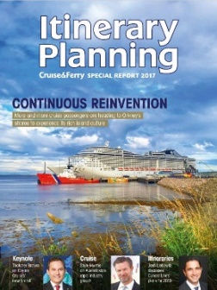

Regional reports
A series of interviews, commentaries and reports about ports, destinations and shore excursions in each of the following regions:
- North America & Canada
- Alaska
- Caribbean & Central America
- South America
- Northern Europe
- Mediterranean & Black Sea
- Africa, Gulf & Indian Ocean
- Asia Pacific
- Australia & New Zealand

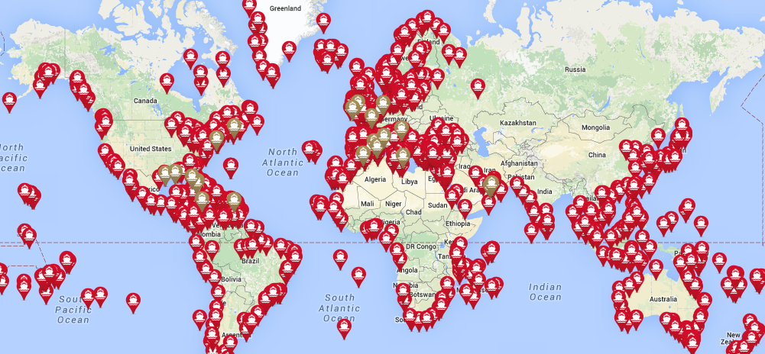
www.cruiseandferry.net/resources/cruise-ports-of-the-world

FURTHER INFORMATION
2018 events
Copies of International Cruise & Ferry Review will be available at the following events:

- Seatrade Cruise Global
- Marine Hotel Association Conference
- Passenger Ship Safety Conference
- Ferry Safety & Technology Conference
- Shippax Ferry Conference
- Green Port Cruise Conference
- Poisidonia Sea Tourism Forum
- MedCruise General Assembly
- Cruise Europe Conference
- Cruise Baltic Conference
- SMM
- Interferry AGM
- CLIA Executive Partner Summit
- International Cruise Summit

Partners
International Cruise & Ferry Review is proud to partner with the following industry organisations:

Contacts
Rebecca Gibson, Associate Editor Jon Ingleton, Executive Editor
Email: rebecca.gibson@tudor-rose.co.uk Email: jon.ingleton@tudor-rose.co.uk
Tel: +44 (0)116 222 9900 Tel: +44 (0)116 222 9900

Note: this editorial plan is subject to the interview availability of the organisations and individuals listed. Wherever possible alternative contributors will be found when they are required.

