Editorial Highlights
Spring/Summer 2019

UPFRONT
Keynote
Arnold Donald, president and CEO of Carnival Corporation, provides the keynote for our first issue of 2019, sharing his thoughts about the continued evolution of the cruise brands under his leadership. Donald’s regular annual contribution to International Cruise & Ferry Review continues to be an essential read.

Marketwatch
An eclectic round-up of the top global cruise and ferry news, views, opinions and insights that cover all segments of the passenger shipping industry.

CRUISE BUSINESS
Roundtable
Boardroom priorities: Our roundtable in this issue invites cruise line CEOs to share insights about their brand vision and highlight the short- to medium-term priorities that will strengthen their market position. Our contributors present a united front on many topics, but the nuances of their individual brands inevitably yield some interesting variety in the discussion.

PLUS Executive interviews with:
- Richard Meadows, president, Seabourn
- Neil Palomba, president, Costa Cruises
- Tom Wolber, president and CEO, Crystal Cruises
- Jeff Vahle, president, Disney Signature Experiences
- Thatcher Brown, president, Dream Cruises
- Stein Kruse, CEO, Holland America Group
- Jan Swartz, president, Princess Cruises
- Michael Bayley, president, Royal Caribbean International
- Wybcke Meier, CEO, TUI Cruises
- Frank J. Del Rio, president and CEO, Norwegian Cruise Line Holidings
- tbc, CEO, Cruise Lines Industry Association

FERRY BUSINESS
Roundtable: New ship technologies
Our first roundtable of 2019, chaired by Simon Johnson, asks ferry owners to comment on the various initiatives that they’re championing as they work towards more sustainable operations. Their responses will likely demonstrate a significant commitment to improving the environmental performance of their fleets and acknowledge that passengers are becoming increasingly discerning about their transportation choices.

PLUS Executive interviews with:
- Mike Corrigan, CEO, Interferry
- Niels Smedegaard, CEO and president, DFDS
- Andrew Sheen, managing director, Irish Ferries
- Kym Sayers, CFO, Spirit of Tasmania
- Merideth Tall, founder and chair, Clipper Navigation
- Margaret Llewellyn OBE, independent chair, The Wales Route Supervisory Board
- Roger Armson, head of Irish Sea operations, P&O Ferries
- William MacLachlan, senior associate, HFW
- Michael Grey, freelance correspondent

BUILDING & REFURBISHMENT
Feature
Cruise order book – cruise line and shipyard executives share their highlights and talk about recent launches. We also review the progress being made on key newbuilds that are due to debut in H1 2018. Contributors include:
- Trevor Young, vice president of newbuilding, MSC Cruises
- Olav Nakken, vice president of newbuilding, Hurtigruten
- Jon Rusten, senior project advisor, Viking Cruises

Ship name | Cruise Line | Shipyard | Delivery date
Scenic Eclipse | Scenic | Uljanik | January 2019
Viking Jupiter | Viking Cruises | Ficantieri | February 2019
MSC Bellissima | MSC Cruises | STX France | March 2019
Costa Venezia | Costa Asia | Fincantieri | March 2019
Mein Schiff 2 | TUI Cruises | Meyer Turku | March 2019
Coral Adventurer | Coral Expeditions | Fincantieri/Vard | March 2019
Hanseatic Nature | Hapag-Lloyd Cruises | Fincantieri/Vard | April 2019
Hondius | Oceanwide Expeditions | Brodosplit | May 2019
Celebrity Flora | Celebrity Cruises | De Hoop | May 2019
Roald Amundsen | Hurtigruten | Kleven Werft | May 2019
Spectrum of the Seas | Royal Caribbean International | Meyer Werft | June 2019

Report: Below deck
Our feature report presents a series of short stories from product and service suppliers who help to kit out the latest cruise and ferry newbuilds. Suppliers share engine, propeller, scrubber, fuel, HVAC, ballast water, electrical, water and other product news about their latest releases, providing details about the expected performance improvement metrics they offer.

PLUS:
- Ferry order book – a review of the highlights in the global order book that are continuing to keep this industry sector buoyant
- Repair and refurbishment highlights – highlights of significant projects completed in H2 2018 and a look ahead to some of the deliveries scheduled for 2019.

MARINE OPERATIONS
Feature: The C&F GREEN LIST
Passenger shipping companies are continuously seeking and implementing sustainability projects to reduce their environmental impact. Many are little known and under-reported. In March we will publish our third C&F Green List, showcasing a collection of products and services across a multitude of industry sub-sectors that can contribute to improving the environmental performance of passenger ships.

Interview: People first
During the State of the Industry debate at Seatrade Cruise Global 2018, Carnival Corporation’s president and CEO Arnold Donald stated that his company must recruit over 34,000 staff annually. We speak to John McGirl, chief human resources officer at Norwegian Cruise Line, to investigate the principles, systems and processes that must be implemented to manage staff recruitment and retention.

PLUS:
- Safety and security
- Telecommunications
- Water and waste management
- Environmental and hygiene
- Heating, ventilation and air conditioning

ONBOARD EXPERIENCE
Feature: Perfecting the dining experience
The standard of onboard dining continues to rise, in no small part due to the design, equipment and furnishings of galleys and restaurants. In this feature we explore some of the extraordinary galleys and eateries onboard the latest generation of cruise ships and ferries. Contributors include:
- Gerald Mosslinger, vice president of hotel operations, Seabourn
- Karl Muhlberger, vice president of hotel operations, Norwegian Cruise Line
- Brian Abel, senior vice president of hotel operations, Celebrity Cruises
- Frank Weber, senior vice president of hotel operations, Virgin Voyages

Report: Interior showcase
Onshore fashion moves at quite a pace, but at sea, interior fabrics, furnishings and other products need to remain relevant and look great until the next refurbishment. In this report we look at a selection of the latest interior products being released by suppliers for a long and on-trend life at sea.

PLUS:

- Interior design and outfitting
- Food and beverage
- Deck and equipment
- Entertainment and systems

NEW in June 2019… Cruise & Ferry Interiors celebrates the work of the individuals
and companies whose creative genius and endeavour combine
to deliver amazing interiors at sea. It’s the official magazine for
Cruise Ship Interiors Expo, and the only one in the delegate bag.

For more information email Shelly Palmer or your Cruise & Ferry
account manager.

It’s the only magazine in the inudstry and will
be the only magazine in the delegate bag!

PORTS & DESTINATIONS
Feature: Memorable destinations
Ports, cruise networks and tourist boards take a moment to highlight what makes their destinations unique and memorable, sharing their top tips for shorex planners to include in the future programmes. Our cruise line contributors will give their general perspective about what makes a destination special:
- Marc Miller, director of deployment and itinerary planning, Royal Caribbean Cruises Ltd
- Mario Parodi, vice president of port and itinerary planning, Norwegian Cruise Line Holdings
- Ugo Savino, director of deployment and itinerary planning, Carnival Cruise Line
- Paul Grigsby, vice president of revenue planning and analytics, Holland America Line

Interview: A planner’s perspective
Itinerary planners are regulars on the speaker circuit and we are often treated to some gems of wisdom. In a new series of interviews over the next few years we will talk to a selection of these familiar and well-informed industry experts to get the inside track on key issues. News will follow shortly about the first planner on our feature interview itinerary.
NEXT ISSUE: September 2019
ITINERARY PLANNING: SPECIAL REPORT 2019
Still the only publication dedicated entirely to the multi-disciplinary activities comprising itinerary planning – an essential read for every stakeholder. E-mail Kimberley McLean for more information.

Regional reports
A series of interviews, commentaries and reports about ports, destinations and shore excursions in each of the following regions:
- North America & Canada
- South America
- Central America & Caribbean
- Northern Europe
- Mediterranean & Black Sea
- Middle East
- Africa, Gulf & Indian Ocean
- Asia Pacific

www.cruiseandferry.net/resources/cruise-ports-of-the-world
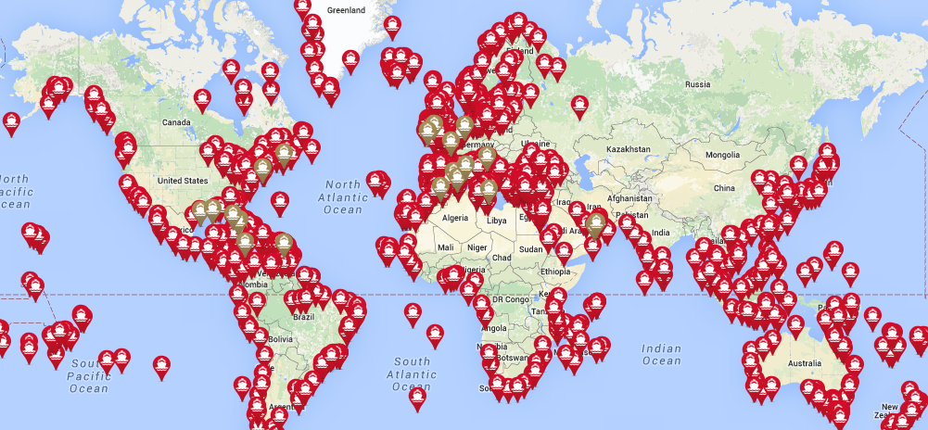

FURTHER INFORMATION
2019 Events
Copies of Cruise & Ferry magazines will be available at the following events:
- Ferry Safety & Technology Conference
- Ferry Shipping Conference
- Seatrade Cruise Global
- Poisidonia Sea Tourism Forum
- Norshipping
- Cruise Ship Interiors Expo (C&F Interiors)
- 7th Mediterranean Ports & Shipping
- Electric & Hybrid Marine World Expo
- Europort
- Adriatic Sea Forum
- Cruise Baltic Conference
- Cruise Europe Conference
- GreenPort Congress
- MedCruise General Assembly
- CFOA Conference
- IMPA
- Interferry
- Oceans 2019
- Crew Connect 2019
- Sustainable Ocean Summit
- Motorship Propulsion & Future Fuels
- Int. Cruise Summit (Itinerary Planning)

Partners
International Cruise & Ferry Review is proud to partner with the following industry organisations:

Contacts
Rebecca Gibson, Associate Editor Jon Ingleton, Executive Editor
Email: rebecca.gibson@tudor-rose.co.uk Email: jon.ingleton@tudor-rose.co.uk
Tel: +44 116 222 9900 Tel: +44 116 222 9900

Note: this editorial plan is subject to the interview availability of the organisations and individuals listed. Alternative contributors will be found if they are required.

